AI-Based Medical Diagnosis System
Design Document

Version 1.0



Group Id: S26PROJECT020A0
Supervisor Name : Amna Bibi

Revision History
Date (dd/mm/yyyy) | Version | Description | Author
15/07/2026 | 1.0 | Introduction of the project | BC250215198
15/10/2026 | 1.1 | Revised ERD using Crow's Foot notation with all entities (including Symptom Dictionary and Model Metadata); added a separate Database Design diagram; added inheritance, composition, and aggregation relationships to the Class Diagram; added page numbers to the Table of Contents; added "Tested By" field to all test cases and added TC-17–TC-22 for newly implemented functionality | BC250215198

Table of Contents

Table of Contents
1. Introduction of Design Document 4
2. Entity Relationship Diagram (ERD) 6
3. Sequence Diagrams 7
4. Architecture Design Diagram 23
5. Class Diagram 24
6. Database Design 25
7. Interface Design 26
8. Test Cases 29
TC-01: User Registration 29
TC-02: User Login 29
TC-03: Submit Symptoms 29
TC-04: NLP Symptom Extraction 30
TC-05: Disease Prediction 30
TC-06: Rule Engine Validation 30
TC-07: Explainable AI 31
TC-08: Save Diagnosis 31
TC-09: View Diagnosis History 31
TC-10: Download PDF Report 32
TC-11: Doctor Validation 32
TC-12: Submit Doctor Feedback 32
TC-13: Manage Expert Rules 33
TC-14: Dataset Management 33
TC-15: User Management 33
TC-16: View Audit Logs 34
TC-17: Multi-Model Training 34
TC-18: Model Activation 34
TC-19: Ranked Disease Predictions 35
TC-20: Persisted Symptom Dictionary 35
TC-21: Usage Statistics Dashboard 35
TC-22: User Deactivation Enforcement 36

1. Introduction of Design Document
This Design Document presents the detailed design of the AI-Based Medical Diagnosis System using NLP & Machine Learning. The document serves as a technical blueprint for the development phase by transforming the requirements defined in the Software Requirements Specification (SRS) into a structured system design.
The proposed system is a web-based intelligent healthcare support application that assists users in identifying possible diseases based on symptoms entered in natural language. The system utilizes Natural Language Processing (NLP), Machine Learning (ML), Explainable Artificial Intelligence (XAI), and rule-based medical reasoning to generate transparent and understandable diagnostic results. The application supports multiple user roles including Patient/User, Doctor, and Administrator, each having specific responsibilities and system privileges.
The primary purpose of this design document is to provide a clear description of the system architecture, data structures, software components, database design, user interfaces, and interactions among different modules. It acts as a reference guide for developers during implementation and helps ensure that the final software product remains consistent with the approved requirements.
This document includes the following design artifacts:
- Entity Relationship Diagram (ERD) describing the database entities and relationships.
- Sequence Diagrams illustrating interactions between users and system components for major use cases.
- Architecture Design Diagram showing the tiered architecture and communication flow among frontend, backend, database, NLP engine, machine learning models, and rule engine.
- Class Diagram representing the major software classes and their relationships.
- Database Design defining collections/tables, attributes, and constraints.
- Interface Design presenting the proposed graphical user interfaces of the application.
- Test Cases validating functional requirements and use case scenarios.
The system follows a three-tier architecture consisting of a presentation layer, application layer, and data layer. The frontend is developed using React.js to provide a responsive and user-friendly interface. The backend is implemented using Python Flask, which exposes REST APIs responsible for authentication, symptom processing, prediction generation, report management, and administrative operations. MongoDB is used for storing user information, diagnosis history, symptom dictionaries, expert rules, datasets, and system records.
Several intelligent modules are integrated within the application architecture. The NLP module performs symptom extraction, spelling correction, synonym mapping, severity detection, and duration extraction. The Feature Engineering module converts extracted information into structured numerical vectors suitable for machine learning processing. The Machine Learning module uses Decision Tree, Naive Bayes, and Random Forest algorithms to generate disease predictions. A Hybrid Rule Engine applies expert medical rules and priority-based adjustments to improve diagnostic reasoning. The Explainable AI module generates human-readable explanations showing influential symptoms and decision factors behind each prediction.
To improve reliability and safety, the system incorporates configurable confidence threshold logic. If prediction confidence falls below the predefined threshold, the system requests additional symptom information rather than presenting uncertain diagnoses. The application also displays a medical disclaimer indicating that the system is intended for educational purposes only and should not be considered a substitute for professional medical advice.
Additional design considerations included in the system are role-based access control, JWT-based authentication, dataset validation, diagnosis history management, PDF report generation, logging and audit tracking, and administrative monitoring capabilities. These features ensure that the application remains maintainable, secure, explainable, and suitable for academic evaluation.
The Design Phase plays a critical role in the software development life cycle because it converts requirements into a detailed implementation plan. A well-structured design reduces development risks, improves communication among team members, facilitates testing activities, and provides a foundation for future system enhancements. Through this design document, stakeholders can clearly understand how the AI-Based Medical Diagnosis System will be constructed and how its various components will work together to achieve the project objectives.

2. Entity Relationship Diagram (ERD)

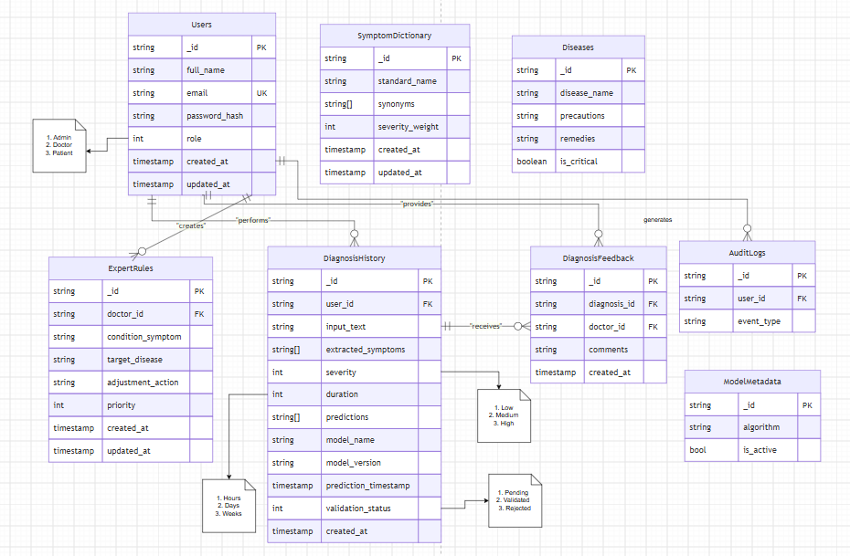
3. Sequence Diagrams
UC-01: Register User 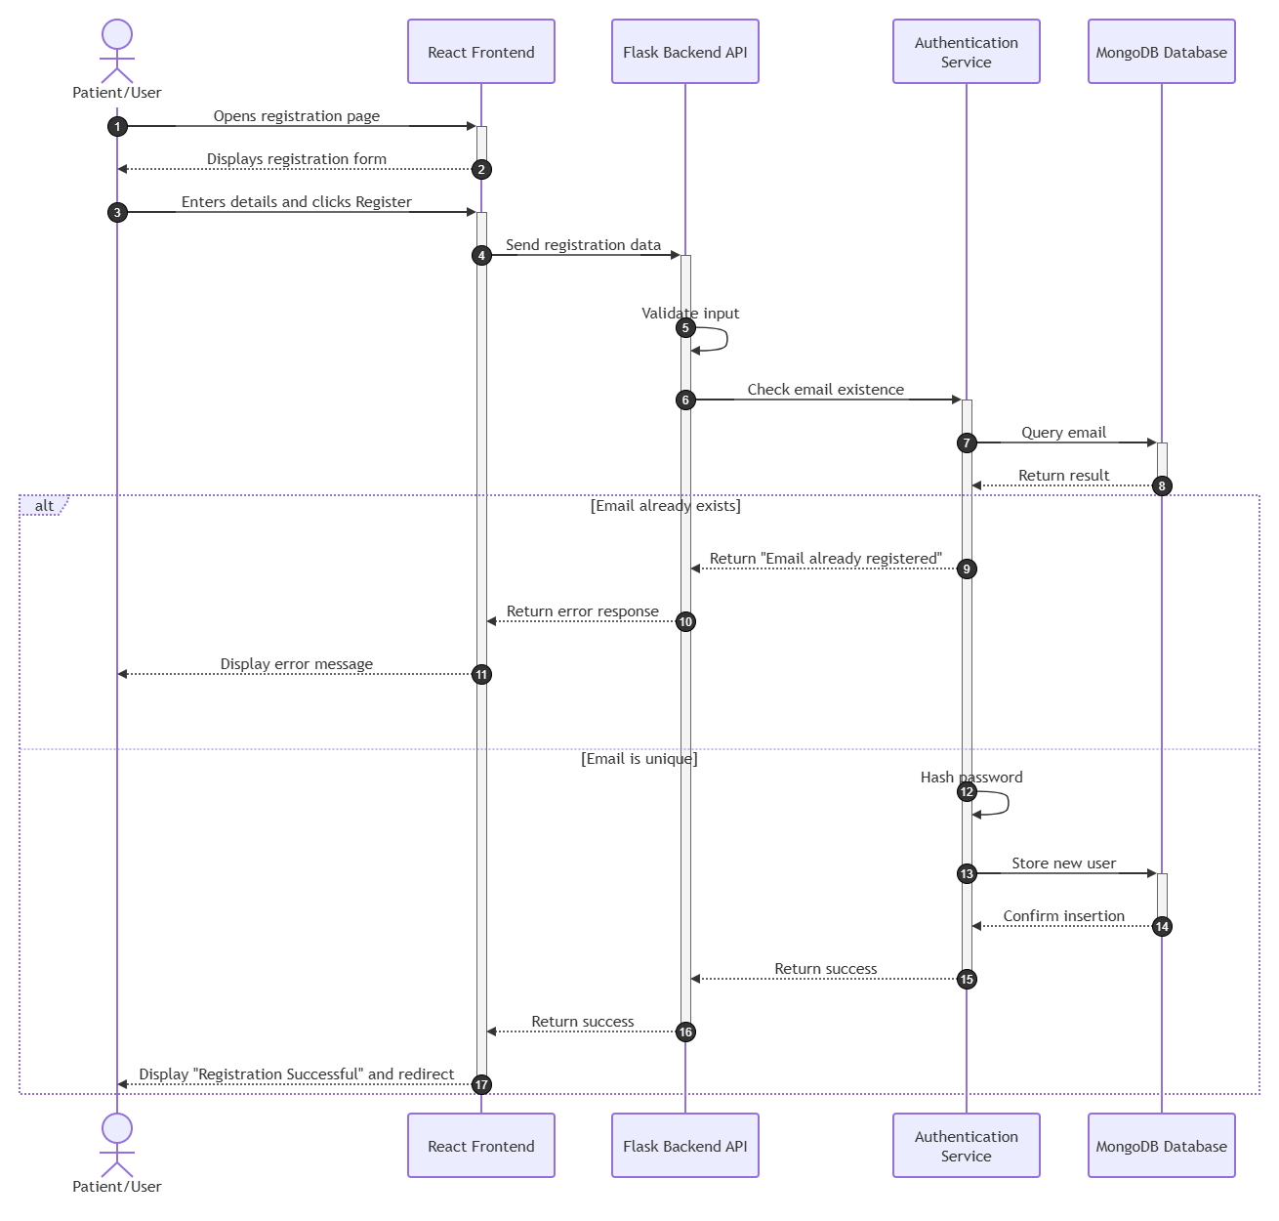

UC-02: Login
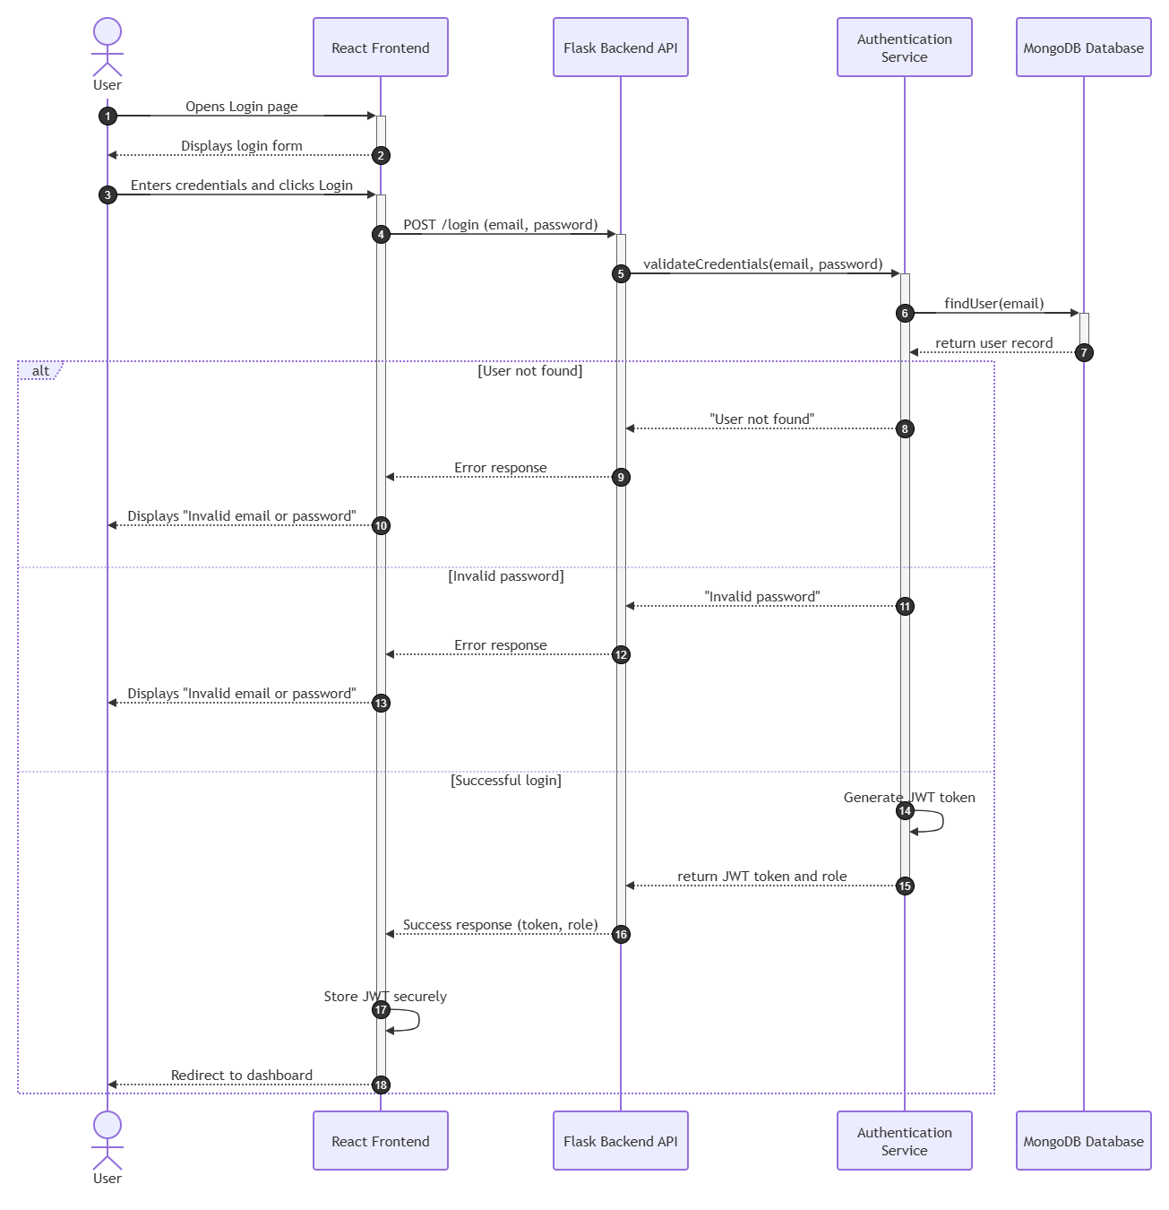

UC-03: Submit Symptoms
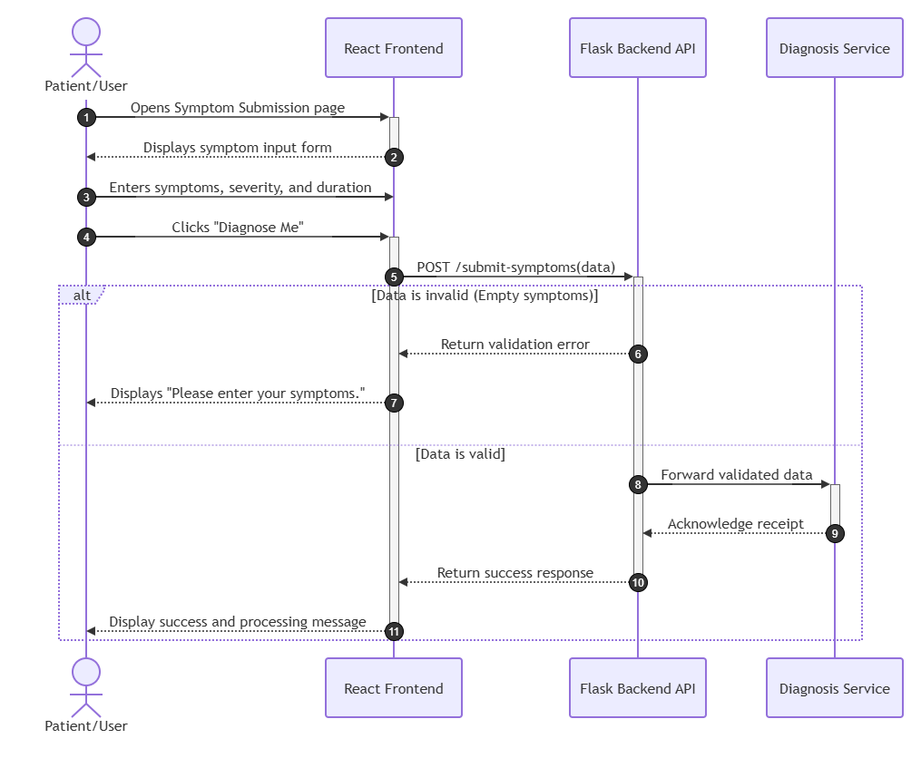

UC-04: Receive Diagnosis
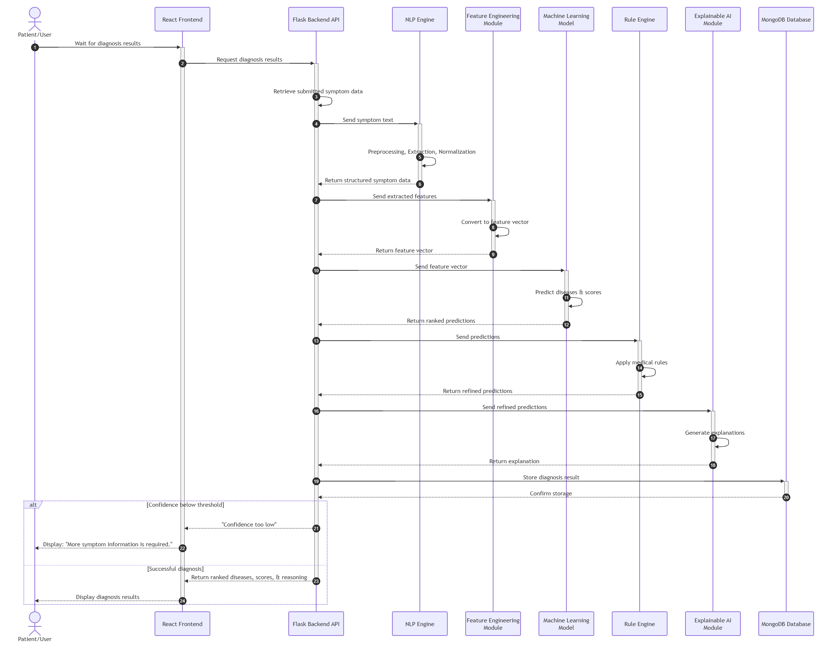

UC-05: View Diagnosis Explanation
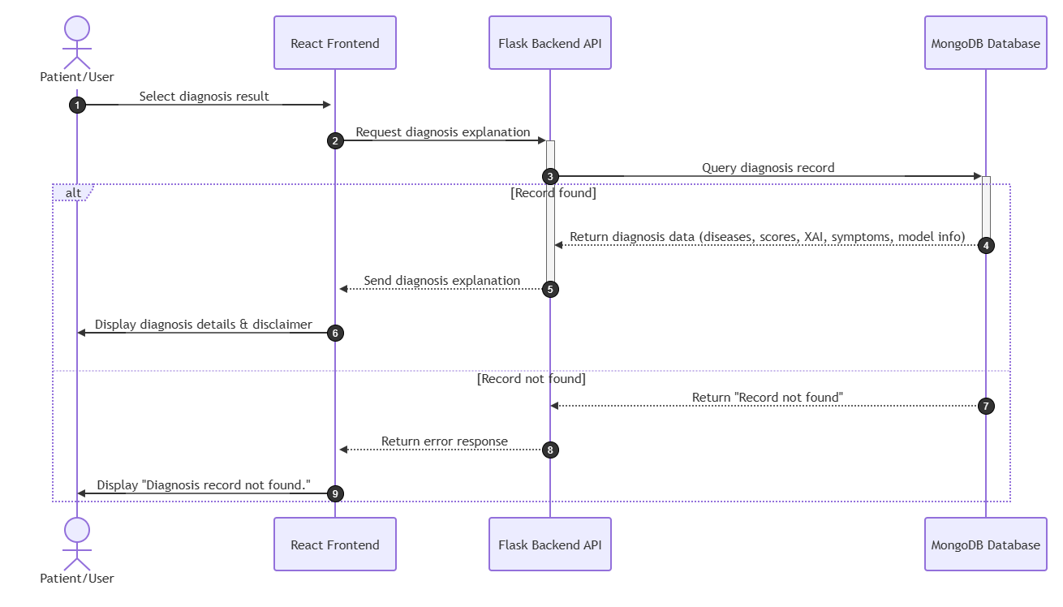

UC-06: Save Diagnosis
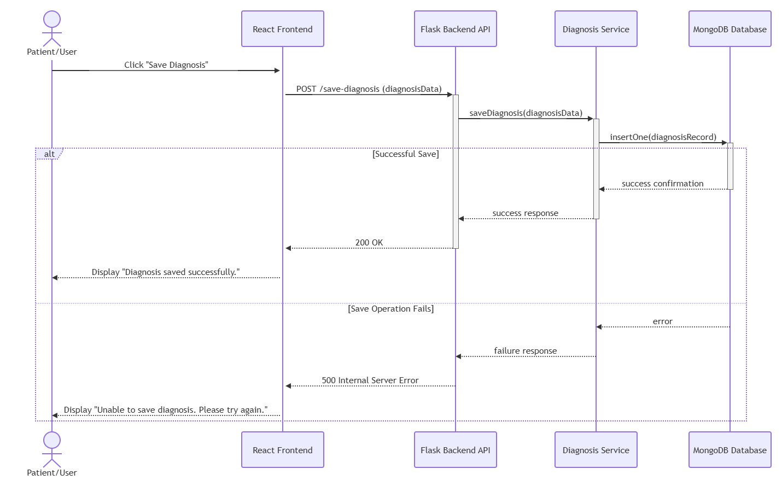

UC-07: View History
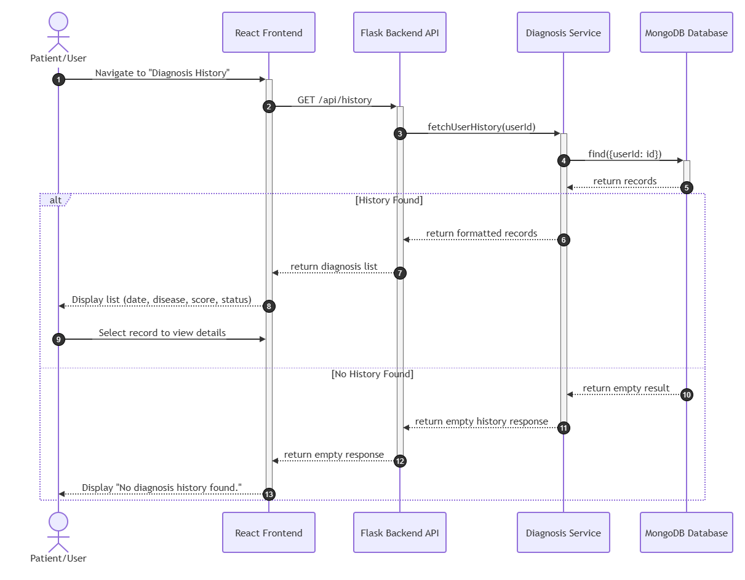

UC-08: Download Report
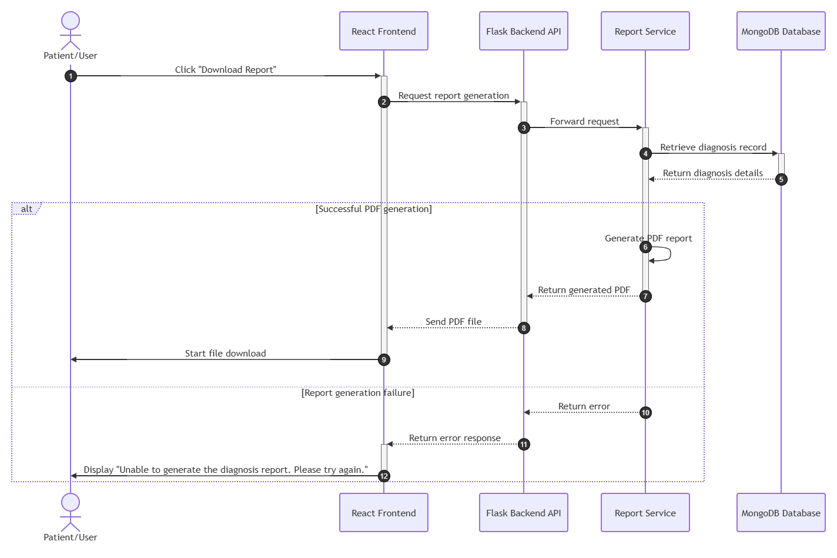

UC-09: Logout
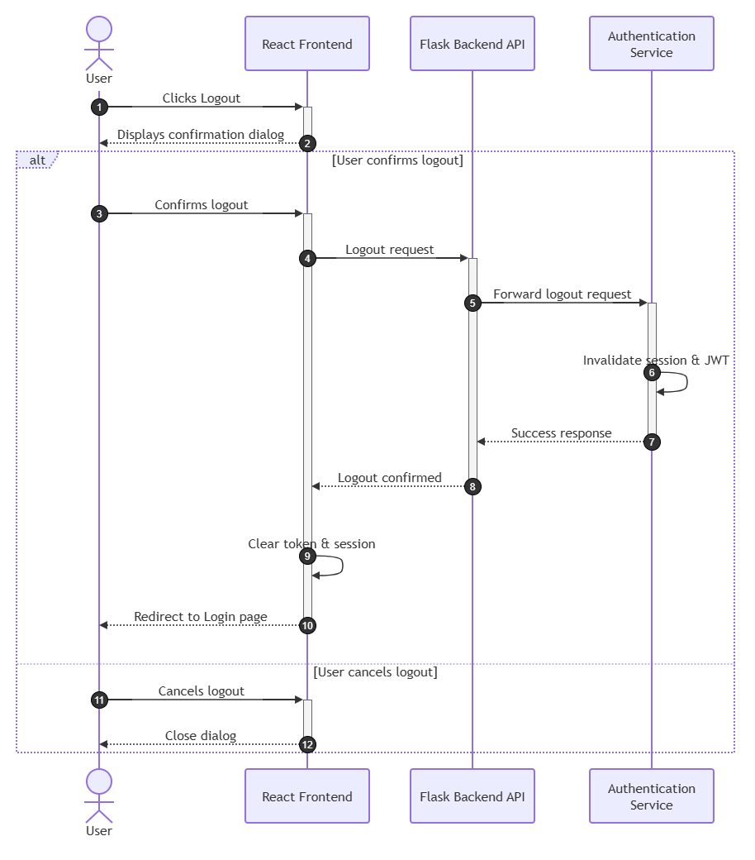

UC-10: Validate Diagnosis
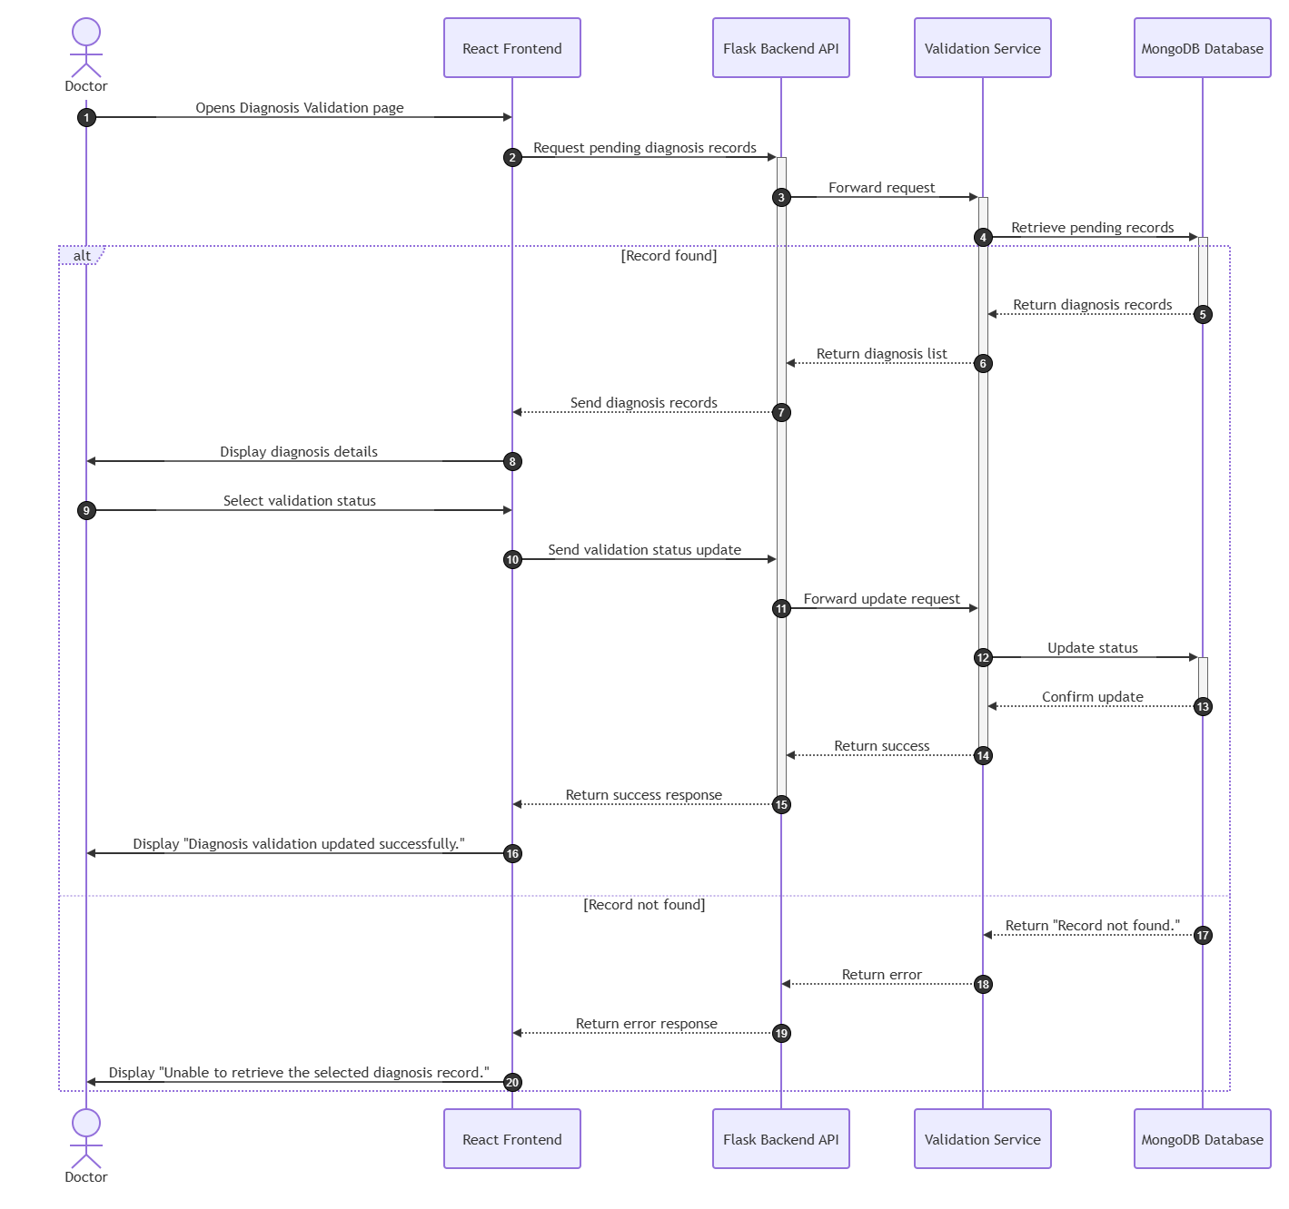

UC-11: Provide Feedback
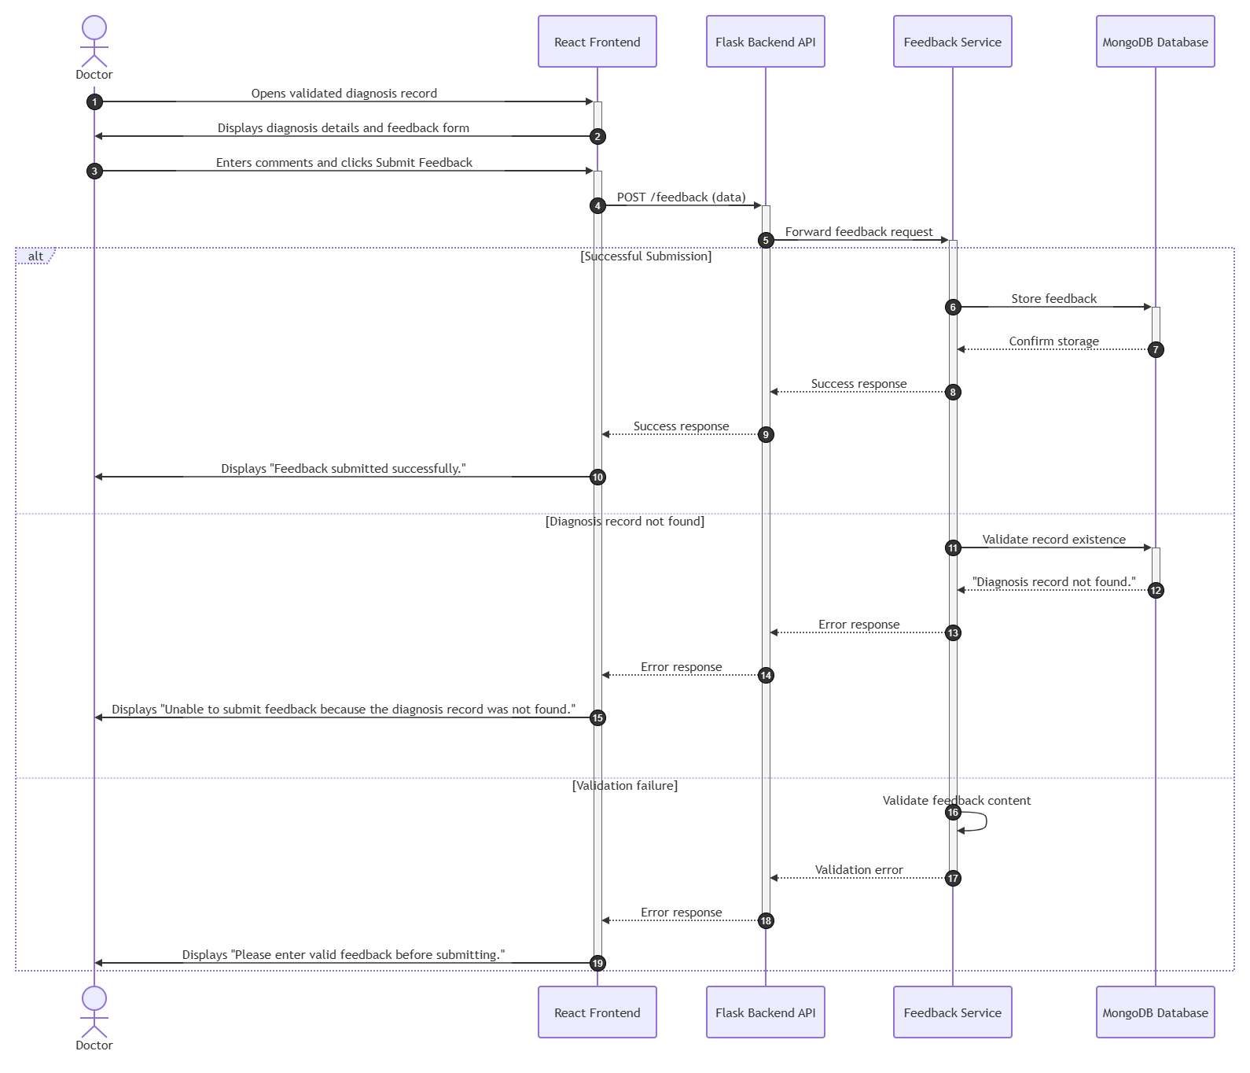

UC-12: Manage Expert Rules
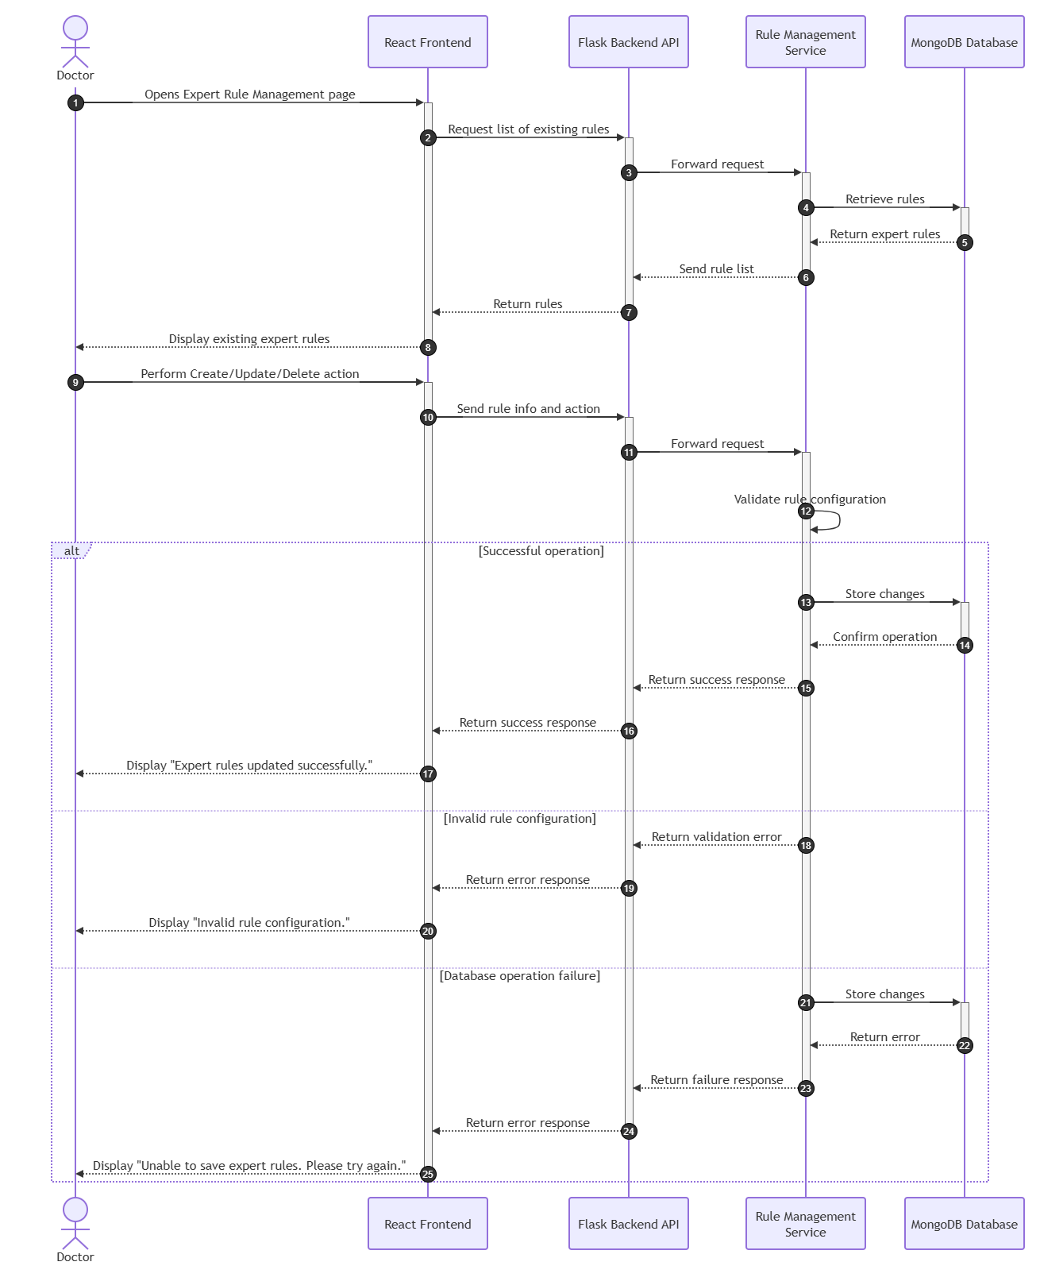
UC-13: Manage Datasets
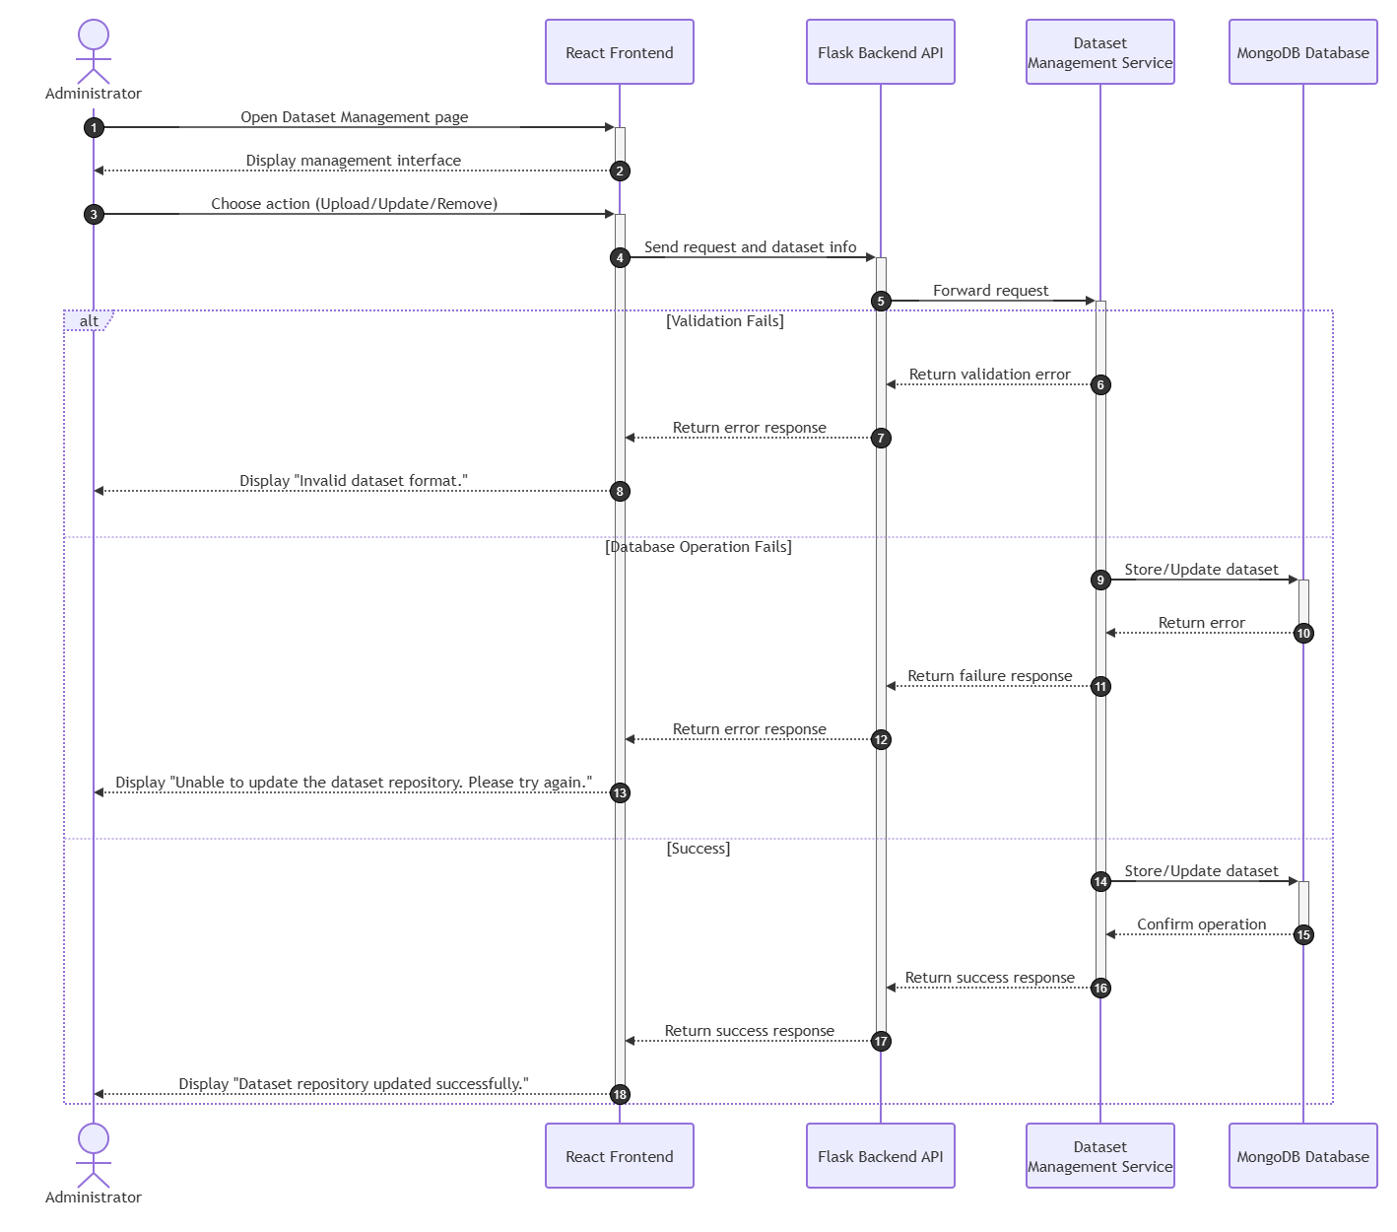

UC-14: Monitor System Performance
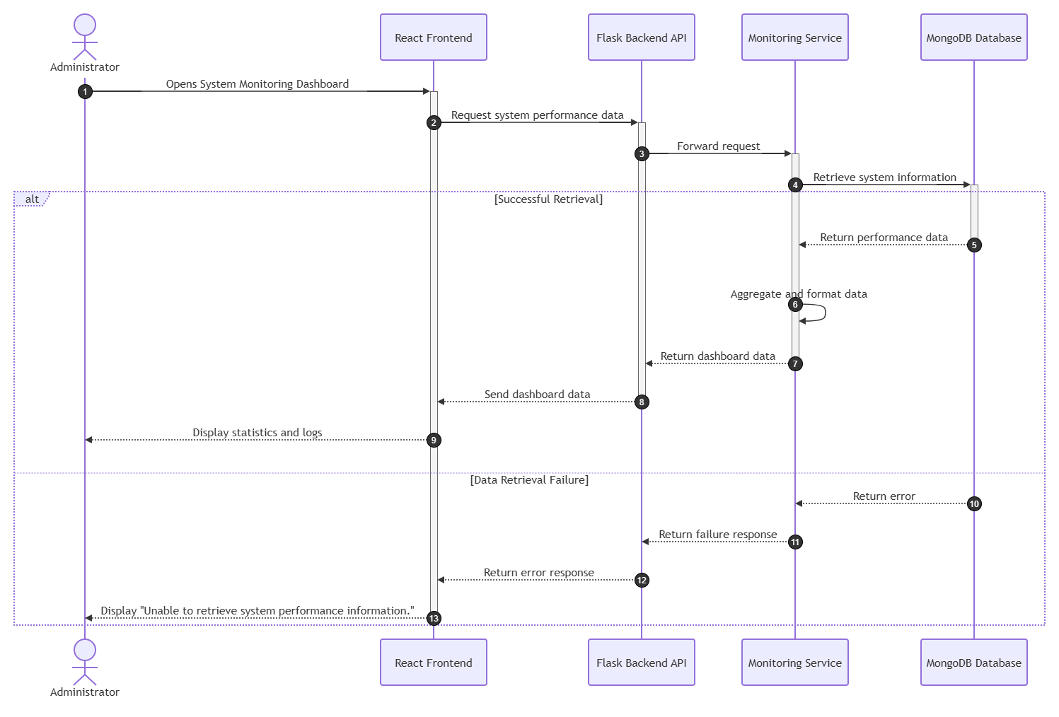

UC-15: Manage Users
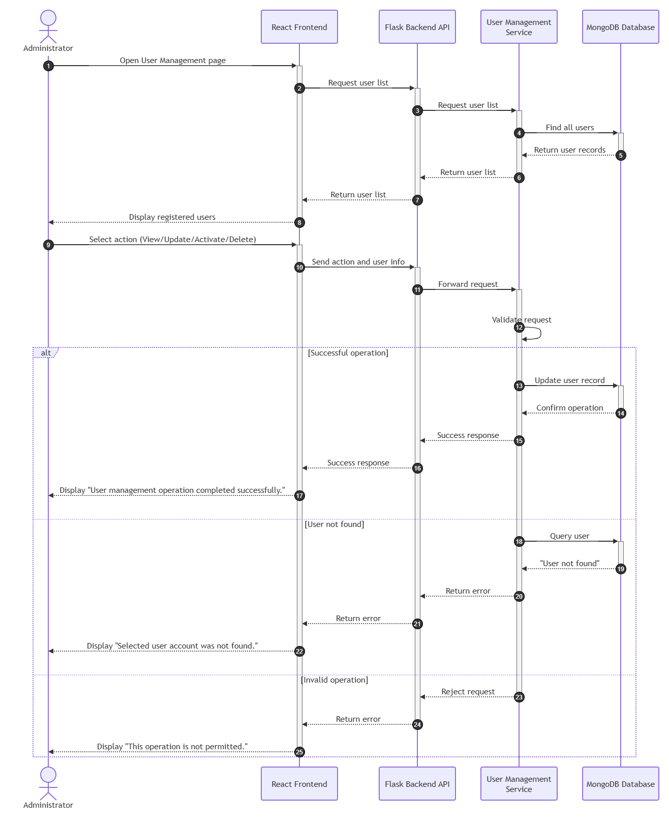
UC-16: View Audit Logs
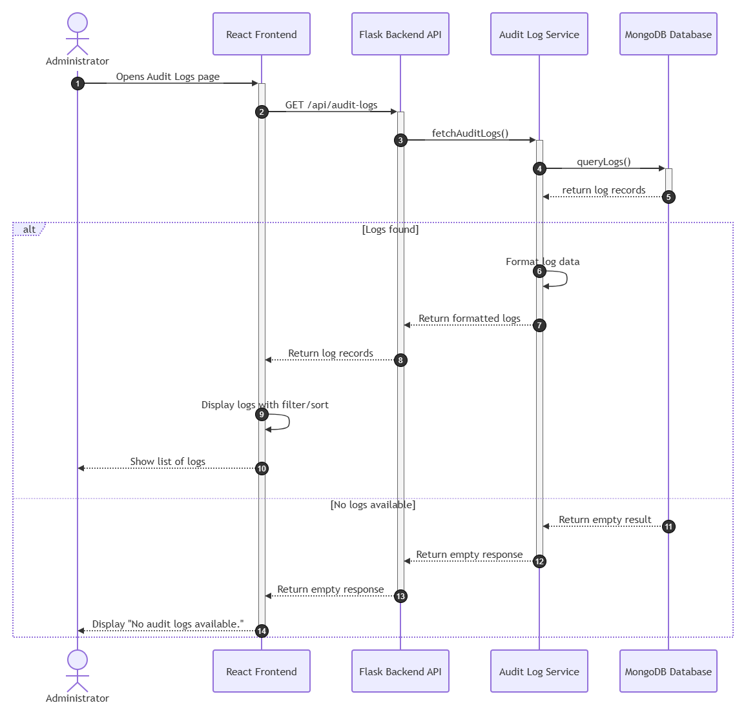

4. Architecture Design Diagram
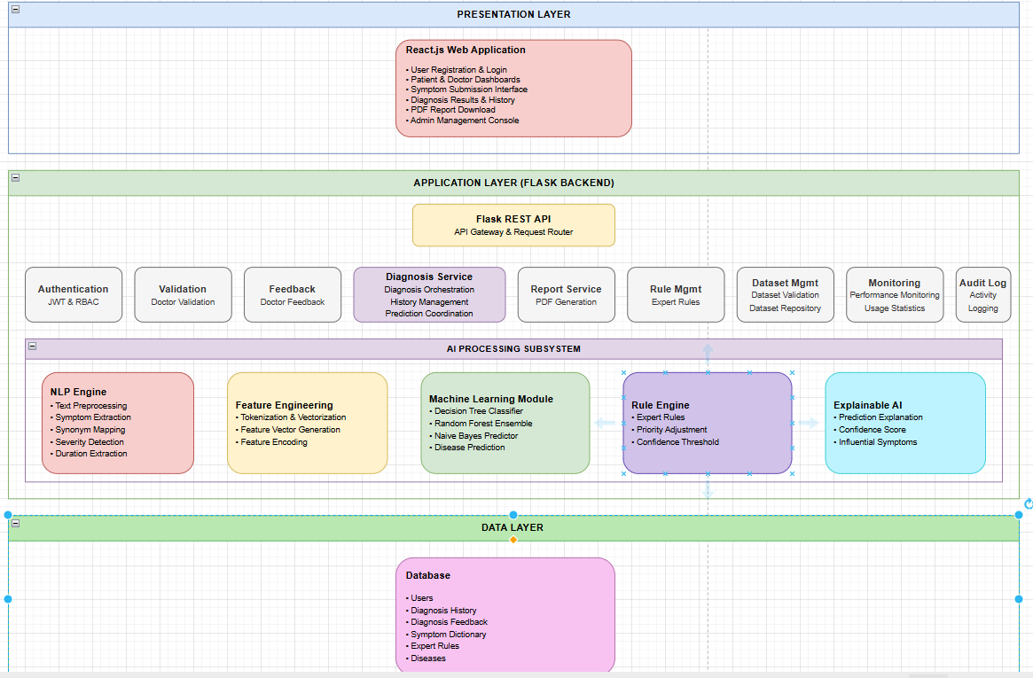

5. Class Diagram

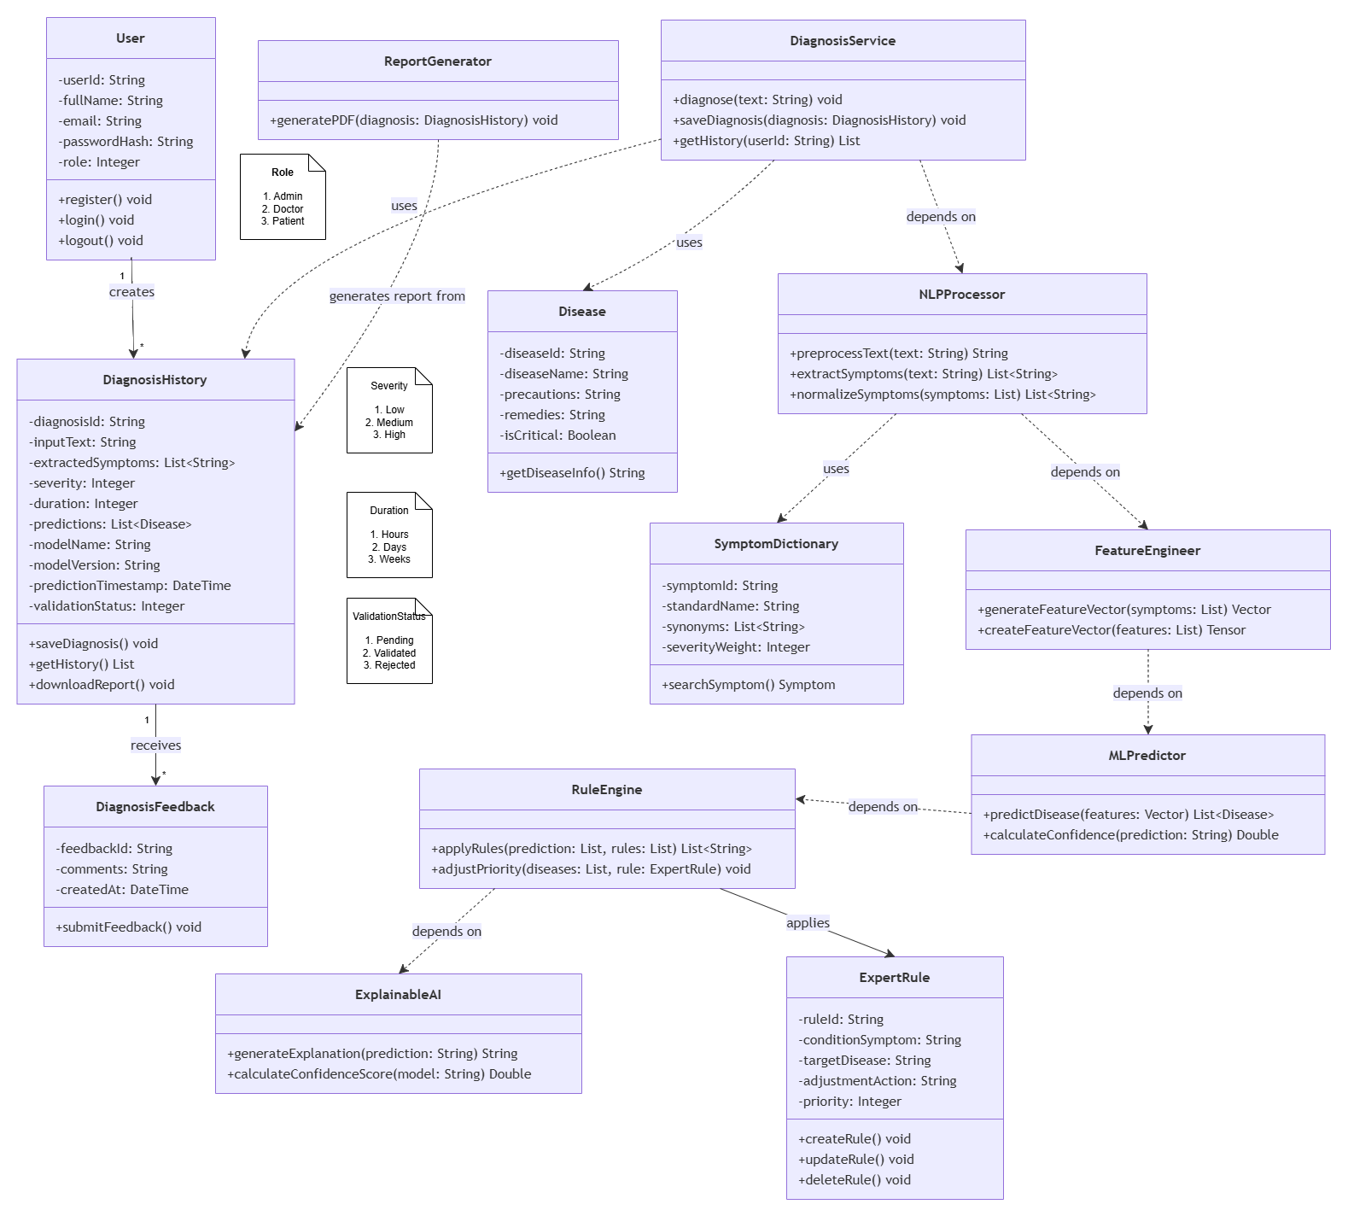

6. Database Design

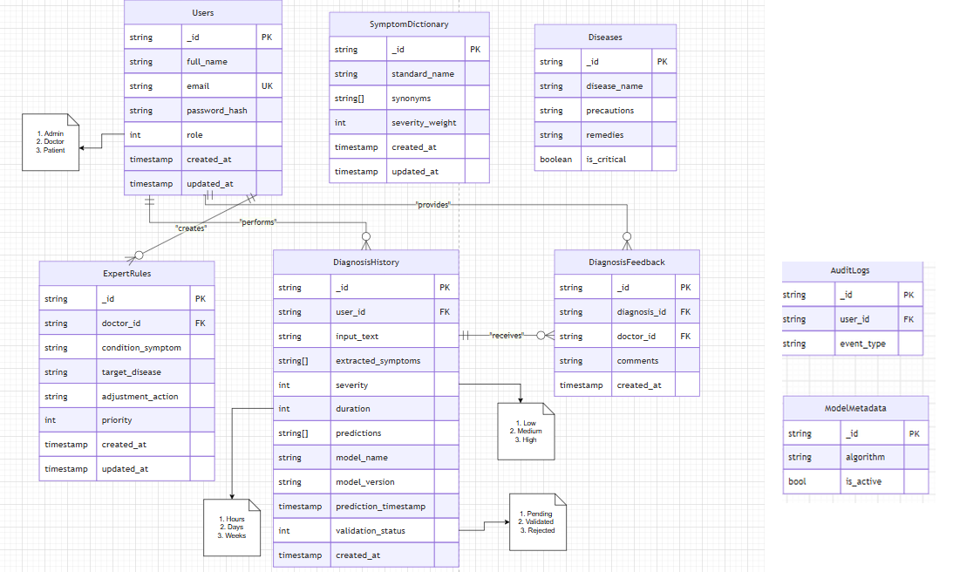

7. Interface Design

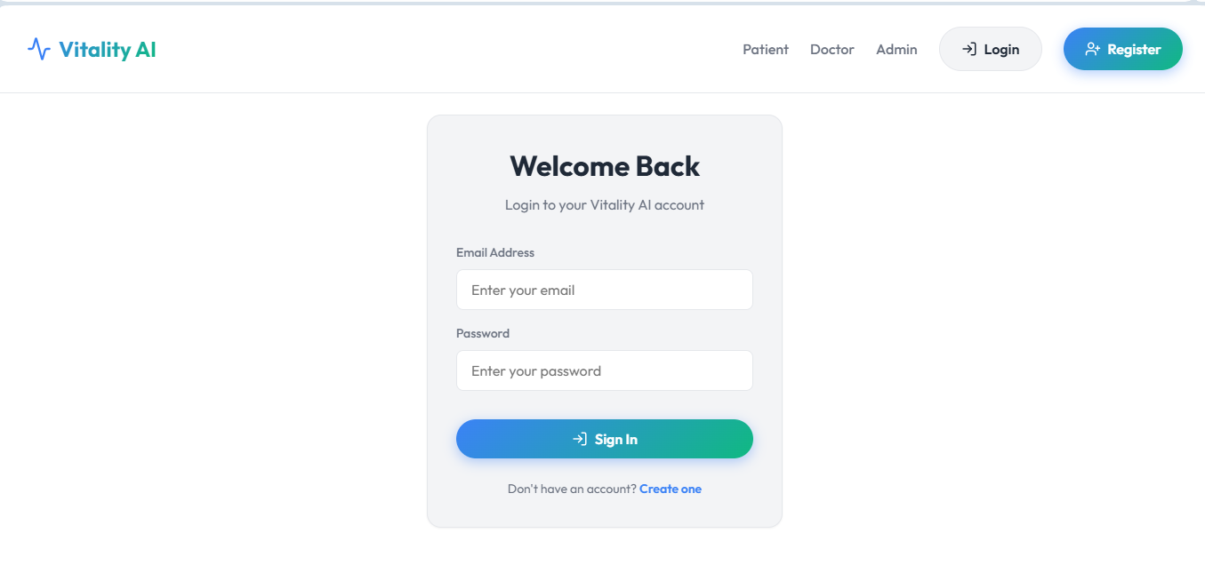

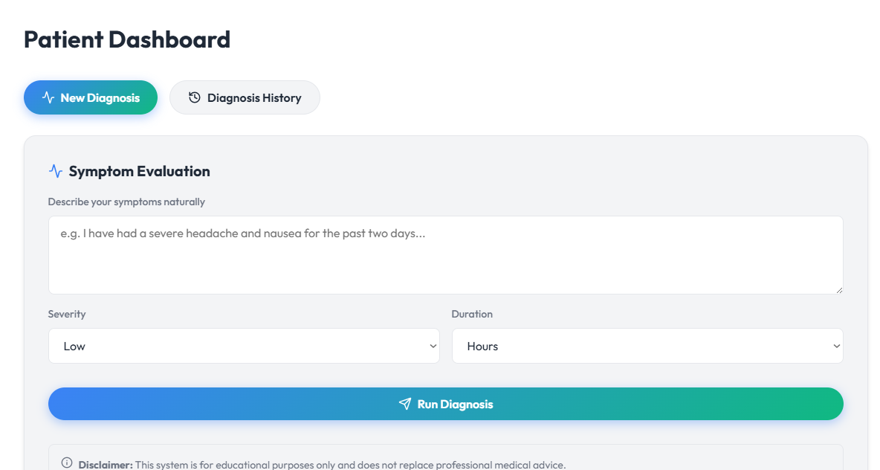

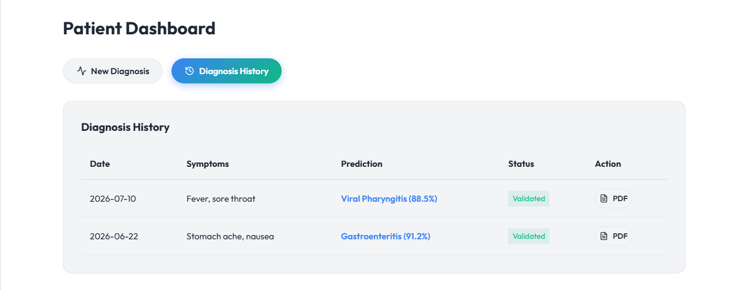
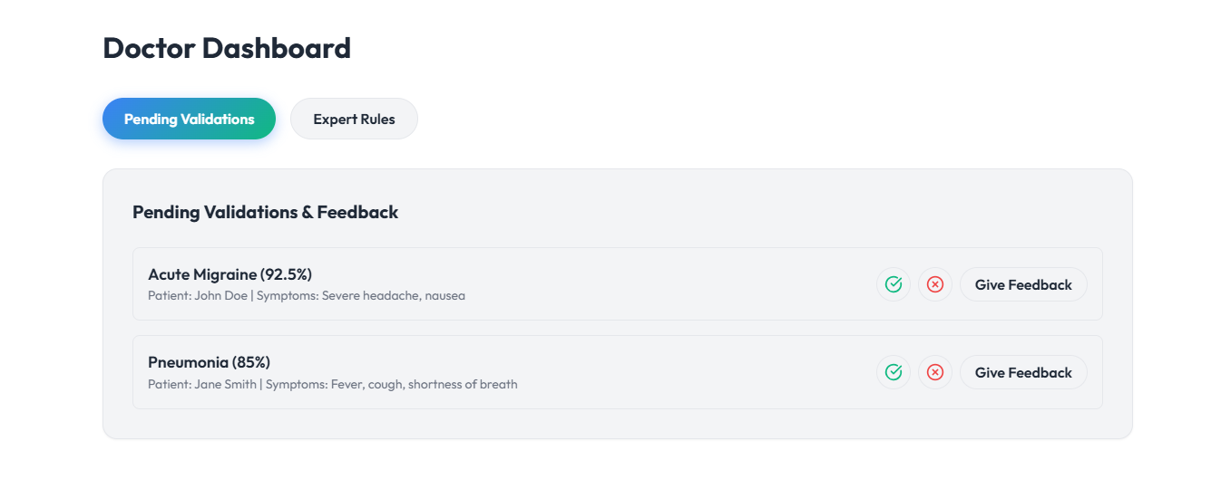
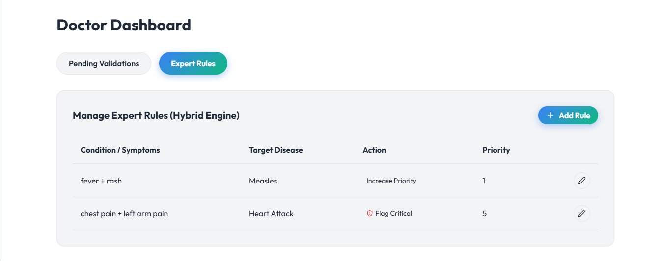

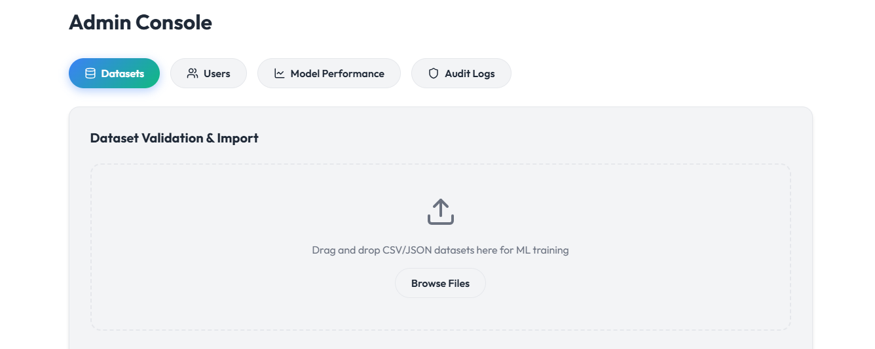

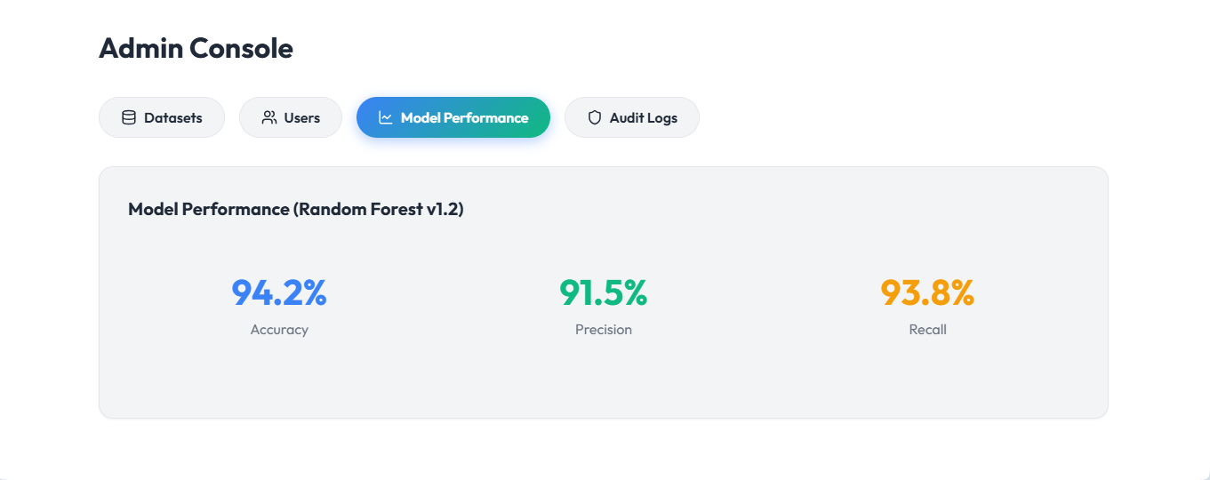

- Test Cases

TC-01: User Registration
Field | Value
Test Case ID | TC-01
Test Case Name | User Registration
Preconditions | User is not registered.
Test Steps | 1. Open Registration page.2. Enter valid Full Name, Email, Password, and Confirm Password.3. Click Register.
Expected Result | User account is created successfully and redirected to the Login page.
Status | Pass
Tested By | BC250215198

TC-02: User Login
Field | Value
Test Case ID | TC-02
Test Case Name | User Login
Preconditions | User account exists.
Test Steps | 1. Open Login page.2. Enter valid Email and Password.3. Click Login.
Expected Result | User is authenticated and redirected to the appropriate dashboard.
Status | Pass
Tested By | BC250215198

TC-03: Submit Symptoms
Field | Value
Test Case ID | TC-03
Test Case Name | Submit Symptoms
Preconditions | Patient is logged in.
Test Steps | 1. Open Submit Symptoms page.2. Enter symptoms.3. Select severity and duration.4. Click Submit.
Expected Result | Symptoms are accepted and diagnosis processing starts.
Status | Pass
Tested By | BC250215198

TC-04: NLP Symptom Extraction
Field | Value
Test Case ID | TC-04
Test Case Name | NLP Symptom Extraction
Preconditions | Symptoms submitted.
Test Steps | Submit natural-language symptom text.
Expected Result | Symptoms are correctly extracted and normalized.
Status | Pass
Tested By | BC250215198

TC-05: Disease Prediction
Field | Value
Test Case ID | TC-05
Test Case Name | Disease Prediction
Preconditions | Feature vector generated.
Test Steps | Execute prediction process.
Expected Result | System returns ranked predicted diseases with confidence scores.
Status | Pass
Tested By | BC250215198

TC-06: Rule Engine Validation
Field | Value
Test Case ID | TC-06
Test Case Name | Apply Expert Rules
Preconditions | Initial predictions generated.
Test Steps | Execute Rule Engine.
Expected Result | Expert rules adjust prediction priorities when applicable.
Status | Pass
Tested By | BC250215198

TC-07: Explainable AI
Field | Value
Test Case ID | TC-07
Test Case Name | Generate Explanation
Preconditions | Final predictions available.
Test Steps | Request diagnosis explanation.
Expected Result | Explanation and confidence score are displayed.
Status | Pass
Tested By | BC250215198

TC-08: Save Diagnosis
Field | Value
Test Case ID | TC-08
Test Case Name | Save Diagnosis
Preconditions | Diagnosis completed.
Test Steps | Click Save Diagnosis.
Expected Result | Diagnosis record is stored successfully in the database.
Status | Pass
Tested By | BC250215198

TC-09: View Diagnosis History
Field | Value
Test Case ID | TC-09
Test Case Name | View Diagnosis History
Preconditions | Saved diagnosis exists.
Test Steps | Open Diagnosis History page.
Expected Result | Previous diagnosis records are displayed.
Status | Pass
Tested By | BC250215198

TC-10: Download PDF Report
Field | Value
Test Case ID | TC-10
Test Case Name | Download Diagnosis Report
Preconditions | Diagnosis exists.
Test Steps | Click Download PDF.
Expected Result | Diagnosis report is generated and downloaded successfully.
Status | Pass
Tested By | BC250215198

TC-11: Doctor Validation
Field | Value
Test Case ID | TC-11
Test Case Name | Validate Diagnosis
Preconditions | Doctor is logged in.
Test Steps | Review a diagnosis and mark it as Validated or Rejected.
Expected Result | Validation status is updated successfully.
Status | Pass
Tested By | BC250215198

TC-12: Submit Doctor Feedback
Field | Value
Test Case ID | TC-12
Test Case Name | Submit Feedback
Preconditions | Diagnosis reviewed.
Test Steps | Enter comments and submit feedback.
Expected Result | Feedback is stored and linked to the diagnosis.
Status | Pass
Tested By | BC250215198

TC-13: Manage Expert Rules
Field | Value
Test Case ID | TC-13
Test Case Name | Manage Expert Rules
Preconditions | Doctor logged in.
Test Steps | Create, update, or delete an expert rule.
Expected Result | Rule changes are saved successfully.
Status | Pass
Tested By | BC250215198

TC-14: Dataset Management
Field | Value
Test Case ID | TC-14
Test Case Name | Dataset Validation & Import
Preconditions | Administrator logged in.
Test Steps | Upload and validate a dataset.
Expected Result | Dataset is successfully validated and imported.
Status | Pass
Tested By | BC250215198

TC-15: User Management
Field | Value
Test Case ID | TC-15
Test Case Name | User Management
Preconditions | Administrator logged in.
Test Steps | Create, edit, or deactivate a user account.
Expected Result | User information is updated successfully.
Status | Pass
Tested By | BC250215198

TC-16: View Audit Logs
Field | Value
Test Case ID | TC-16
Test Case Name | View Audit Logs
Preconditions | Administrator logged in.
Test Steps | Open the Audit Logs page.
Expected Result | System activity logs are displayed correctly.
Status | Pass
Tested By | BC250215198

TC-17: Multi-Model Training
Field | Value
Test Case ID | TC-17
Test Case Name | Multi-Model Training
Preconditions | Administrator logged in; dataset uploaded.
Test Steps | Click "Retrain Random Forest Model" on the Datasets tab.
Expected Result | Decision Tree, Naive Bayes, and Random Forest are all trained, with accuracy, precision, and recall recorded for each.
Status | Pass
Tested By | BC250215198

TC-18: Model Activation
Field | Value
Test Case ID | TC-18
Test Case Name | Model Activation
Preconditions | Multiple trained models exist in Model Performance.
Test Steps | Select a non-active model and click Activate.
Expected Result | Subsequent diagnoses use the newly activated model's name and version.
Tested By | BC250215198
Status | Pass

TC-19: Ranked Disease Predictions
Field | Value
Test Case ID | TC-19
Test Case Name | Ranked Disease Predictions
Preconditions | Diagnosis submitted.
Test Steps | View the Results page.
Expected Result | Top-3 predicted diseases are displayed with individual confidence percentages.
Tested By | BC250215198
Status | Pass

TC-20: Persisted Symptom Dictionary
Field | Value
Test Case ID | TC-20
Test Case Name | Persisted Symptom Dictionary
Preconditions | Administrator adds a new synonym.
Test Steps | Restart the backend server, then submit a diagnosis using that synonym.
Expected Result | The synonym still resolves correctly after the restart.
Tested By | BC250215198
Status | Pass

TC-21: Usage Statistics Dashboard
Field | Value
Test Case ID | TC-21
Test Case Name | Usage Statistics Dashboard
Preconditions | Administrator logged in; diagnosis records exist.
Test Steps | Open the Usage Statistics tab.
Expected Result | Total counts, daily trend, top diseases, and role/validation breakdowns render correctly.
Tested By | BC250215198
Status | Pass

TC-22: User Deactivation Enforcement
Field | Value
Test Case ID | TC-22
Test Case Name | User Deactivation Enforcement
Preconditions | Administrator logged in; target user holds an active session token.
Test Steps | Deactivate the target user's account.
Expected Result | The user's existing session token is immediately rejected, not just blocked at next login.
Tested By | BC250215198
Status | Pass

